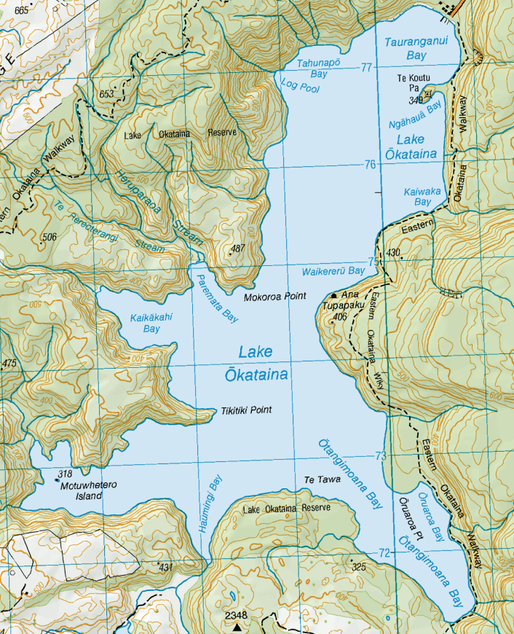

First Aid/ Onshore Base/ Entry and Exit

Support Vessels based around course, one typically on each race mark

Sailing Area